INDEX

1 OBJECIVE
2 Hardware & Software Specification
3 IMPLEMENTATION

4 SYSTEM DESIGN
- FLOW CHART

- DATABASE DESIGN

5 OUTPUT
6 SYSTEM INTEGRATION AND TESTING
7 FUTURE SCOPE OF THE PROJECT
8 CONCLUSION

9 REFERENCES

CHAPTER 1

OBJECTIVE

This software is providing better facility to user. This software provides facility to user to manage all information about Hotel. This software automatic calculates total Bills. Using this software paper work is reduced. This software provides fast searching and print facility to user. Using This Software user search Customer Details And generate New Bill. This System Provide better Gui to user.

Front End - Vb. Net is used as a Front End, Vb. Net is a object oriented Programming Language For Software Development. Vb. Net is a Platform Independent Language.

Back End – Microsoft Access Is a Back End In this Project. Microsoft Access is support All Sql Query to Performed any Operation in Data base.
Like select, Insert, Delete, Updated Etc.

CHAPTER 2

Hardware & Software Specification

Hardware Specification

Processor : - Pentium- iv 2.4 GHz

RAM : - 512 MB

Hard Disk : - 1 Gb

Key Board : - 110 Keys

Software specification

Front-end Package : - Microsoft VB .Net

Back-end : - SQL SERVER

Operating System : - Windows Xp Or Higher Version.

2.1 SELECTED SOFTWARE

INTRODUCTION TO .NET FRAMEWORK
The Microsoft .NET Framework is a software technology that is available with several Microsoft Windows operating systems. It includes a large library of pre-coded solutions to common programming problems and a virtual machine that manages the execution of programs written specifically for the framework. The .NET Framework is a key Microsoft offering and is intended to be used by most new applications created for the Windows platform.

The pre-coded solutions that form the framework's Base Class Library cover a large range of programming needs in a number of areas, including user interface, data access, database connectivity, cryptography, web application development, numeric algorithms, and network communications. The class library is used by programmers, who combine it with their own code to produce applications.

Programs written for the .NET Framework execute in a software environment that manages the program's runtime requirements. Also part of the .NET Framework, this runtime environment is known as the Common Language Runtime (CLR). The CLR provides the appearance of an application virtual machine so that programmers need not consider the capabilities of the specific CPU that will execute the program. The CLR also provides other important services such as security, memory management, and exception handling. The class library and the CLR together compose the .NET Framework.

Principal design features
Interoperability
Because interaction between new and older applications is commonly required, the .NET Framework provides means to access functionality that is implemented in programs that execute outside the .NET environment. Access to COM components is provided in the System .Runtime. Interop Services and System .Enterprise Services namespaces of the framework; access to other functionality is provided using the P/Invoke feature.
Common Runtime Engine

The Common Language Runtime (CLR) is the virtual machine component of the .NET framework. All .NET programs execute under the supervision of the CLR, guaranteeing certain properties and behaviors in the areas of memory management, security, and exception handling.

Base Class Library

The Base Class Library (BCL), part of the Framework Class Library (FCL), is a library of functionality available to all languages using the .NET Framework. The BCL provides classes which encapsulate a number of common functions, including file reading and writing, graphic rendering, database interaction and XML document manipulation.
Simplified Deployment
Installation of computer software must be carefully managed to ensure that it does not interfere with previously installed software, and that it conforms to security requirements. The .NET framework includes design features and tools that help address these requirements.
Security

The design is meant to address some of the vulnerabilities, such as buffer overflows, that have been exploited by malicious software. Additionally, .NET provides a common security model for all applications.

Portability

The design of the .NET Framework allows it to theoretically be platform agnostic, and thus cross-platform compatible. That is, a program written to use the framework should run without change on any type of system for which the framework is implemented. Microsoft's commercial implementations of the framework cover Windows, Windows CE, and the Xbox 360. In addition, Microsoft submits the specifications for the Common Language Infrastructure (which includes the core class libraries, Common Type System, and the Common Intermediate Language), the C# language, and the C++/CLI language to both ECMA and the ISO, making them available as open standards. This makes it possible for third parties to create compatible implementations of the framework and its languages on other platforms.

Architecture

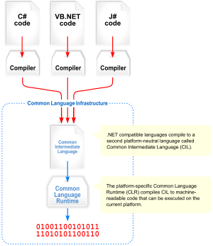
Visual overview of the Common Language Infrastructure (CLI)
Common Language Infrastructure

The core aspects of the .NET framework lie within the Common Language Infrastructure, or CLI. The purpose of the CLI is to provide a language-neutral platform for application development and execution, including functions for exception handling, garbage collection, security, and interoperability. Microsoft's implementation of the CLI is called the Common Language Runtime or CLR.

ADO.NET OVERVIEW

ADO.NET is an evolution of the ADO data access model that directly addresses user requirements for developing scalable applications. It was designed specifically for the web with scalability, statelessness, and XML in mind.
ADO.NET uses some ADO objects, such as the Connection and Command objects, and also introduces new objects. Key new ADO.NET objects include the Dataset, Data Reader, and Data Adapter.

The important distinction between this evolved stage of ADO.NET and previous data architectures is that there exists an object -- the Dataset -- that is separate and distinct from any data stores. Because of that, the Dataset functions as a standalone entity. You can think of the Dataset as an always disconnected record set that knows nothing about the source or destination of the data it contains. Inside a Dataset, much like in a database, there are tables, columns, relationships, constraints, views, and so forth.

A Data Adapter is the object that connects to the database to fill the data Set. Then, it connects back to the database to update the data there, based on operations performed while the Data Set held the data. In the past, data processing has been primarily connection-based. Now, in an effort to make multi-tiered apps more efficient, data processing is turning to a message-based approach that revolves around chunks of information. At the center of this approach is the Data Adapter, which provides a bridge to retrieve and save data between a Data Set and its source data store. It accomplishes this by means of requests to the appropriate SQL commands made against the data store.

The XML-based Data Set object provides a consistent programming model that works with all models of data storage: flat, relational, and hierarchical. It does this by having no 'knowledge' of the source of its data, and by representing the data that it holds as collections and data types. No matter what the source of the data within the Data Set is, it is manipulated through the same set of standard APIs exposed through the DataSet and its subordinate objects.

While the DataSet has no knowledge of the source of its data, the managed provider has detailed and specific information. The role of the managed provider is to connect, fill, and persist the DataSet to and from data stores. The OLE DB and SQL Server .NET Data Providers (System.Data.OleDb and System.Data.SqlClient) that are part of the .Net Framework provide four basic objects: the Command, Connection, DataReader and DataAdapter. In the remaining sections of this document, we'll walk through each part of the DataSet and the OLE DB/SQL Server .NET Data Providers explaining what they are, and how to program against them.
The following sections will introduce you to some objects that have evolved, and some that are new. These objects are:

- Connections. For connection to and managing transactions against a database.
- Commands. For issuing SQL commands against a database.
- DataReaders. For reading a forward-only stream of data records from a SQL Server data source.
- DataSet. For storing, Remoting and programming against flat data, XML data and relational data.
- DataAdapters. For pushing data into a DataSet, and reconciling data against a database.

When dealing with connections to a database, there are two different options: SQL Server .NET Data Provider (System.Data.SqlClient) and OLE DB .NET Data Provider (System.Data.OleDb). In these samples we will use the SQL Server .NET Data Provider. These are written to talk directly to Microsoft SQL Server. The OLE DB .NET Data Provider is used to talk to any OLE DB provider (as it uses OLE DB underneath).
Connections:
Connections are used to 'talk to' databases, and are represented by provider-specific classes such as SqlConnection. Commands travel over connections and resultsets are returned in the form of streams which can be read by a DataReader object, or pushed into a DataSet object.

Commands:
Commands contain the information that is submitted to a database, and are represented by provider-specific classes such as SqlCommand. A command can be a stored procedure call, an UPDATE statement, or a statement that returns results. You can also use input and output parameters, and return values as part of your command syntax. The example below shows how to issue an INSERT statement against the Northwind database.

DataReaders:
The DataReader object is somewhat synonymous with a read-only/forward-only cursor over data. The DataReader API supports flat as well as hierarchical data. A DataReader object is returned after executing a command against a database. The format of the returned DataReader object is different from a recordset. For example, you might use the DataReader to show the results of a search list in a web page.

DATASETS AND DATAADAPTERS:
DataSets
The DataSet object is similar to the ADO Recordset object, but more powerful, and with one other important distinction: the DataSet is always disconnected. The DataSet object represents a cache of data, with database-like structures such as tables, columns, relationships, and constraints. However, though a DataSet can and does behave much like a database, it is important to remember that DataSet objects do not interact directly with databases, or other source data. This allows the developer to work with a programming model that is always consistent, regardless of where the source data resides. Data coming from a database, an XML file, from code, or user input can all be placed into DataSet objects. Then, as changes are made to the DataSet they can be tracked and verified before updating the source data. The GetChanges method of the DataSet object actually creates a second DatSet that contains only the changes to the data. This DataSet is then used by a DataAdapter (or other objects) to update the original data source.
The DataSet has many XML characteristics, including the ability to produce and consume XML data and XML schemas. XML schemas can be used to describe schemas interchanged via WebServices. In fact, a DataSet with a schema can actually be compiled for type safety and statement completion.

DATAADAPTERS (OLEDB/SQL)

The DataAdapter object works as a bridge between the DataSet and the source data. Using the provider-specific SqlDataAdapter (along with its associated SqlCommand and SqlConnection) can increase overall performance when working with a Microsoft SQL Server databases. For other OLE DB-supported databases, you would use the OleDbDataAdapter object and its associated OleDbCommand and OleDbConnection objects.
The DataAdapter object uses commands to update the data source after changes have been made to the DataSet. Using the Fill method of the DataAdapter calls the SELECT command; using the Update method calls the INSERT, UPDATE or DELETE command for each changed row. You can explicitly set these commands in order to control the statements used at runtime to resolve changes, including the use of stored procedures. For ad-hoc scenarios, a CommandBuilder object can generate these at run-time based upon a select statement. However, this run-time generation requires an extra round-trip to the server in order to gather required metadata, so explicitly providing the INSERT, UPDATE, and DELETE commands at design time will result in better run-time performance.
- ADO.NET is the next evolution of ADO for the .Net Framework.
- ADO.NET was created with n-Tier, statelessness and XML in the forefront. Two new objects, the DataSet and DataAdapter, are provided for these scenarios.
- ADO.NET can be used to get data from a stream, or to store data in a cache for updates.
- There is a lot more information about ADO.NET in the documentation.
- Remember, you can execute a command directly against the database in order to do inserts, updates, and deletes. You don't need to first put data into a DataSet in order to insert, update, or delete it.
Also, you can use a DataSet to bind to the data, move through the data, and navigate data relationships
5.4 SQL SERVER
A database management, or DBMS, gives the user access to their data and helps them transform the data into information. Such database management systems include dBase, paradox, IMS, SQL Server and SQL Server. These systems allow users to create, update and extract information from their database.
A database is a structured collection of data. Data refers to the characteristics of people, things and events. SQL Server stores each data item in its own fields. In SQL Server, the fields relating to a particular person, thing or event are bundled together to form a single complete unit of data, called a record (it can also be referred to as raw or an occurrence). Each record is made up of a number of fields.
No two fields in a record can have the same field name. During an SQL Server Database design project, the analysis of your business needs identifies all the fields or attributes of interest. If your business needs change over time, you define any additional fields or change the definition of existing fields

CHAPTER 3
IMPLEMENTATION
3.1ANALYSIS

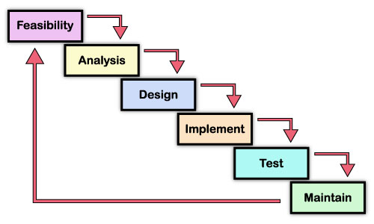
IDENTIFICATION OF THE NEED

The development of the new system contains some activities which try to automate the entire process keeping in view of the database integration approach. The major problem with previous record management system is that it does not provide any statistical way of analyzing and representing the data for further decision making.

PRELIMINARY INVESTIGATION
Preliminary study is an initial exploration of issues related to a proposed quality review or evaluation.The first step in any software development is the identification of need. This is a user’s request to change, improve or enhance an existing system because there is likely to be a stream of such requests standard procedures must be established to deal with them. The preliminary investigation is one way of handling this. The objective is to determine whether the request is valid and feasible or not.
This project also started by collecting information through previous records from existing documentation and questionaires from the user staff.

3.1.1 FEASIBILITY STUDY
An important outcome of the preliminary investigation is the determination that the system requested is feasible. There are a 3 aspects in the feasibility study.
An important outcome of the preliminary investigation is the determination that system requested is feasible. It is proposed to solve the problem development a computer based information system for property tax collection. Since the data is voluminous and involves a lot of overhead. Therefore, it is the best activity for computerization. The proposed system is feasible in following aspects.

3.1.2 OPERATIONAL FEASIBILITY- It is mainly related to human organizati on and political aspects.
The points to be consider are :
* what changes will be brought with the system !.
* what organization structures are distributed !.
* What new skills will be required !.Do existing staff members have
Generally project will not be rejected simply because of operational Infeasibility but such considerations are likely to critically affect the nature and scope or the eventual recommendations. This feasibility study is carries out by a small group of people who are familiar with information system techniques, who understand the parts of the business that are relevant to the project and are skilled in system analysis and design process.
As far as this project is concerned the changes which we have to be brought depends upon whether we are going to build a new project or we goi* Clarify and understand the project request.
* Determine the size of the project.
* Assess costs and benefits of alternative approaches.
* Determine the technical and operational feasibility of alternative approaches.
* Report the finding to management; with recommendation outlining the acceptance or rejection of the proposal.
The operational feasibility is measured by the usage of the system after implementation and resistance from the users. The employees of municipality are extending support and there is no resisting change. Hence, it is encouraging to undertake a detailed system analysis.

3.1.3 TECHNICAL FEASIBILITY
This is concerned with specifying equipment and software that will successfully satisfy the LIC requirement. The technical needs of the system may vary considerably, but might include:
* The facility to produce outputs in a given time.
* Response time under certain conditions.
* Ability to process a certain volume of transaction at a particular speed.
* Facility to communicate data to distant location.
In examining technical feasibility, configuration of the system is given more important than the actual make of hardware. The configuration should give the complete picture about the system’s requirement like how many computer system are required in the organization how these units are interconnected so that they could operate and communicate smoothly. What speed of input and output should be achieved at particular quality of printing. Specific hardware and software products can then be evaluated keeping in view with the
logical needs of the organization.
At the feasibility stage it is desirable that two or three different configurations will be pursued that satisfy the key technical requirements but which represent different levels of ng to modify some establishment in the late one first of all we have make a network environment i.e. establishment of a server is must. Then our focus goes towards workstation. Keeping in view of their hardware requirements like network interface card etc.
Regarding this project distribution of organizational structure is also essential because of security concerns, as there are different departments like Finance, Administration, Back office, Cash Counter etc. having their particular task I have already mentioned earlier like a system administration should have the authentication to provide different access permission to its clients.
There is also another clause to check what skills are required !. By means to say whether the existing staff is capable. The technical feasibility is measured with the current Equipment, existing software technologies and available personnel are sufficient for the proposed system. The proposed system is technically feasible since the equipment, software technology and available personal in the organization are well suitable for the proposed system. The technical issue usually raised during the feasibility stage of the investigation includes the following:

Does the necessary technology exist to do what is suggested?

Can the system be upgraded if developed?

Are there technical guarantees of accuracy, reliability, ease of access and data security?

The current system developed is technically feasible.

The database’s purpose is to create, establish and maintain a workflow among various entities in order to facilitate all concerned users in their various capacities or roles.

It provides the technical guarantee of accuracy, reliability and security.

3.1.4 ECONOMIC FEASIBILITY
Economic analysis is the most frequent used technique for evaluating the effectiveness of a proposed system. More commonly known as cost/ benefit analysis; the procedure is to determine the benefits and saving that expected from a proposed system and compare them with costs. If benefits outweigh costs, a decision is taken to design and implement the system. Otherwise, further justification or alternative in the proposed system will have to be made if it is to have a chance of being approved. This is an ongoing effort that improves an accuracy at each phase of the system life cycle.
This feasibility also depends upon quality of staff hired and the proposed duration of time taken in this project sometimes it might be possible due to extension of time duration may fall the project under loss . The study of feasibility changes from phase to phase of the project development.
In this project although this feasibility study doesn’t matter much in the case new setup of project because we start according to Account specification bit on the other hand if we have to modify over existing system we must take care of our existing resources and must analyses specially the working condition of hardware like server quality etc.

CHAPTER 4

SYSTEM DESIGN

4.1 DESIGN OVERVIEW

System design is a process through which requirements are isolated into a representation of software. The design phase begins, when the requirement specifications are ready thus, system design is the bridge between analysis and development of software. System design phase has two level- Top level Design & Detailed Design. In top level design, the system is broken down into different modules, while in detailed design, the focus is given on the internal design of each module. The objective of the detailed design is to describe the system in such details, so that the development or coding phase can begin.

Design is the first step in the development phase for any engineered product or system. It can be defined as “the process of applying various techniques and principles for the purpose of defining a device, a process or a system in sufficient detail to permit its physical realization”.
Design is basically the technical kernel of software engineering. During design, progressive refinements of data structure, program architecture, interfaces and procedural detail are developed, retrieved and documented. Design results in representations of software that can be assessed for quality.
Design model creation requires information provided by each element of the analysis model. The design step produces a DATA DESIGN, an ARCHITECTURAL DESIGN, an INTERFACE DESIGN and a PROCEDURAL DESIGN.
- Data Design: It transforms the information domain model created during analysis into the data structure that will be required to implement the software.
- Architectural Design: It defines the relationships among major structural elements of the program.
- Interface Design: It describes how the software communicates within itself, to systems that interoperate with it and with humans who use it.
- Procedural Design: It transforms the structural elements of the program architecture into a procedural description of software components.

4.2 DESIGN APPROCH

Objectives Of System Design
The major objective of system design is to develop the best possible design as per the requirement and working environment for operating the system

The best possible design should have following properties:-
- Correctness:- Design should be correct as per the requirement
- Completeness:-Design should have all the components like data structures modules external interface etc.
- Efficiency:-Expensive & scarce resources should be used efficiently by the system.
- Consistency:- They should not be any inconsistency in the design.
After the analysis must be clear what must be done. In system design, he plans how to do it. The objective of the system design is to decide in general how the system should be implemented. Individual physical components, program files, documents, will be identified. During the analysis prepares a blue print for the system.
Actually, the system design is the process of planning a new business system or one to replace or complement an existing system. Analysis what the system should do and design specifies how to do and design specifies how to accomplish the objectives. System design begins with a search for alternative solution.
The design of an information system produces the details that state how a system will meet the requirements identified during system analysis. This process is known as the logical design and the process of development program software is referred to as physical design.
The design process begins by identifying reports and other outputs the system will produce. The system design also describes the data input, calculated or stored. The produces written tell how to process the data and produce the output. The documents containing the design specifications portray the design in many different ways dataflow diagrams, data dictionary, and HIPO charts

- Software design is actually a multi step process that focuses on four distinct attributes of programs: data structure, software architecture, interface representations and procedural details. The design process translates requirements into a representation of software that can be accessed for quality before coding begins.

4.3DESIGN DESCRIPTION

4.3.1 FLOW CHART

Introduction:-

A flowchart is the graphical representation of the steps followed for solving any programming problem or accomplish a task. It is the best tool to develop the program logic.
As a computer cannot think on its own , the programmer has to provide a method to solve a problem. After defining the problem the programmer writes the procedure how to solve the problem. The procedure must be written in the from of a series of steps in a logical sequence. A precise statement of the procedure required for solving a problem is called a algorithm. Having obtained an algorithm for solving a problem, the algorithm is expressed in pictorial form called a flowchart. A flowchart shows the order of operations. It also shows the relationship between the section of the program

The important symbols used in a flow chart
Symbol Explanation

Terminator – Used in start & end of a flow chart

input/output – used to accept the data or display/print the output.

Process – used to show the activity or processing to be performed an data.

Flow lines-used to connect other symbol in a flowchart for showing the sequence of their execution. The default direction of execution is from top to bottom & from left to right for reverse directions the arrow must be used

Decision box- used to check a condition whether is true or false. Depending upon the condition, the program branches in two direction.
Connector- use to connect two parts of flowchart.

Predefined process-used to represent a module of a program.

LOGIN

START

ENTER ID AND PASSWORD

CHECK
IF VALID
N

Y
SHOW MDI AND MENU

STOP

Bill

START

ENTER ALL DETAILS OF Item

CHECK
IF VALID

N

Y
STORE IN DATABASE
And Print

STOP

SEARCH

START

Enter Date For Search

I F VALID

N

Y

SHOW

STOP

DATABASE DESIGN
DESINING THE DATA BASE

It is known fact that the programs cannot be written until the data are defined, so the databases must be defined. The starting point for this process is data dictionary. The records, data structures and elements to be stored in each database are identified and extracted.

Next the analyst codes the source statements for the descriptions and other data structures, and places them on source statement library. Eventually, the programmer will incorporate this source code into the various programs, thus assuring consistency and simplifying the coding process. The databases have been designed in such away that there is no duplication of information and loss of information

DATA DICTIONARY

Data dictionary consists of description of all the data used in the system. It consists of logical characteristics of current systems data stores including name, description, aliases, contents and organization. Data dictionary serves as the basis for identifying database requirements during system design. Data dictionary is a catalog, a depositary of the elements in the system.

The data dictionary is used to manage the details in the large system.
To communicate a common meaning for all system elements, to document the future of the system, to locate errors and omission in the system. Data dictionary contains two types of descriptions for the data flowing through the system attributes and tables. Attributes are grouped together to make up the tables. The most fundamental data level is attributes tables are a
Set of data items, data related to one another and that collectively describes a component in the system. The description of the attributes consists of data names, data descriptions, aliases, length and data values. The description of data structures consists sequence relation ship, selection relation ship, iteration relationship and operational relationship

TABLE DESIGN
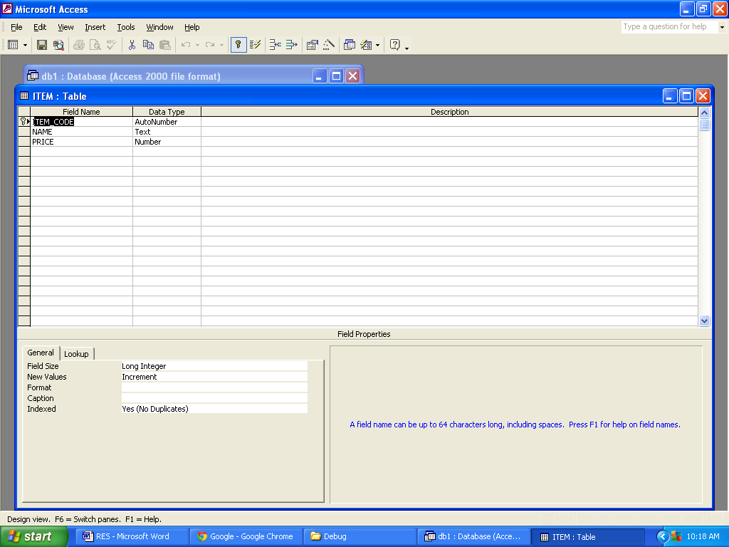

TABLE DATA

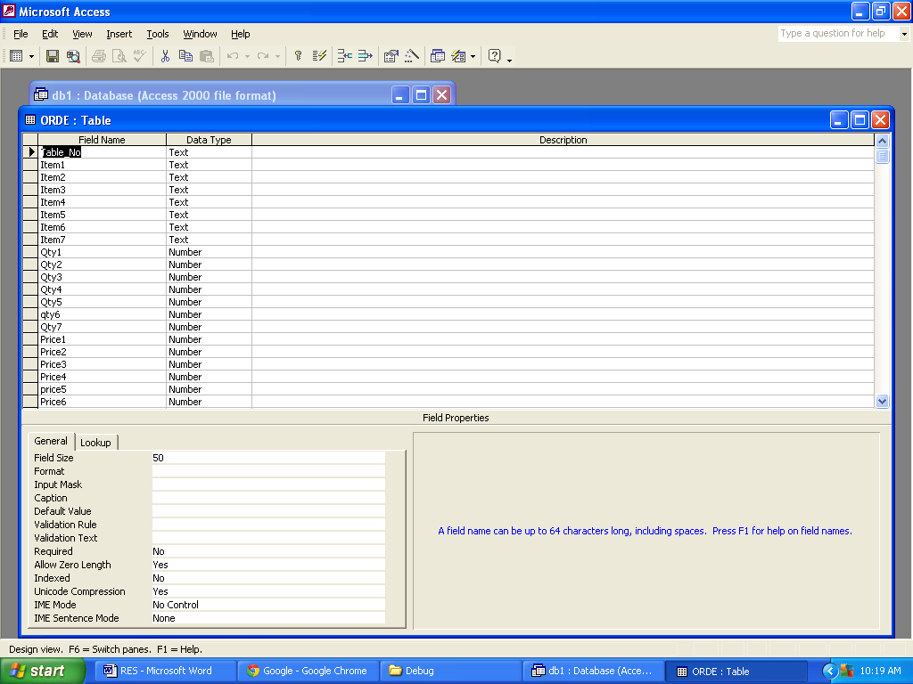

CHAPTER 5

OUTPUT

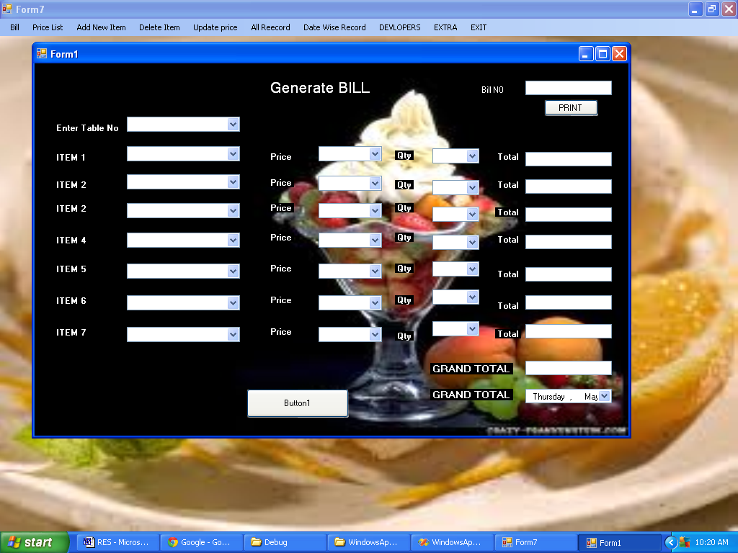

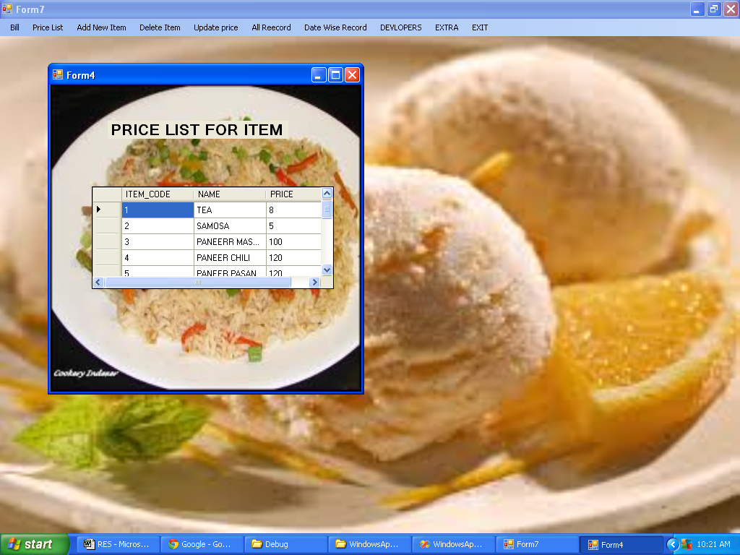

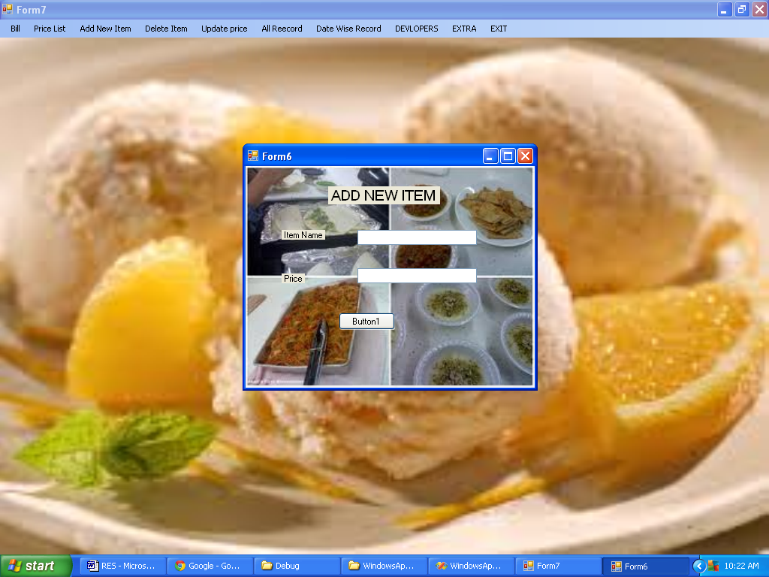

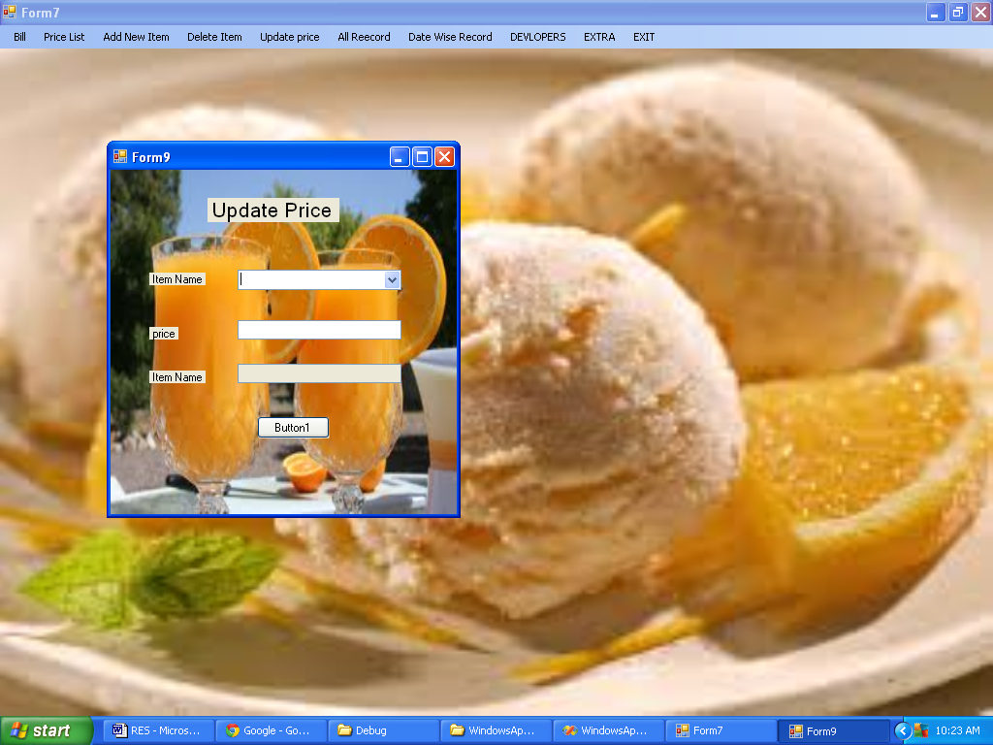

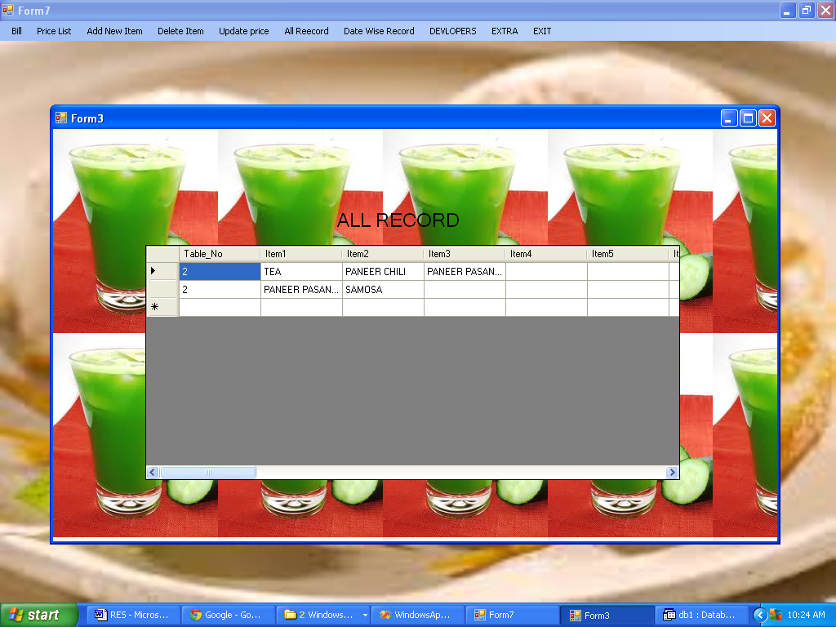

CHAPTER6
SYSTEM INTEGRATION AND TESTING

6-.1 NTRODUCTION
Software testing is a critical element of software quality assurance and represents the ultimate review of specification, design and coding. In fact, testing is the one step in the software engineering process that could be viewed as destructive rather than constructive.
A strategy for software testing integrates software test case design methods into a well-planned series of steps that result in the successful construction of software. Testing is the set of activities that can be planned in advance and conducted systematically. The underlying motivation of program testing is to affirm software quality with methods that can economically and effectively apply to both strategic to both large and small-scale systems.
6.2. STRATEGIC APPROACH TO SOFTWARE TESTING
The software engineering process can be viewed as a spiral. Initially system engineering defines the role of software and leads to software requirement analysis where the information domain, functions, behavior, performance, constraints and validation criteria for software are established. Moving inward along the spiral, we come to design and finally to coding. To develop computer software we spiral in along streamlines that decrease the level of abstraction on each turn.
A strategy for software testing may also be viewed in the context of the spiral. Unit testing begins at the vertex of the spiral and concentrates on each unit of the software as implemented in source code. Testing progress by moving outward along the spiral to integration testing, where the focus is on the design and the construction of the software architecture. Talking another turn on outward on the spiral we encounter validation testing where requirements established as part of software requirements analysis are validated against the software that has been constructed. Finally we arrive at system testing, where the software and other system elements are tested as a whole

UNIT TESTING

MODULE TESTING

SUB-SYSTEM TESING

SYSTEM TESTING
ACCEPTANCE TESTING
Component Testing
Integration Testing
User Testing

6.3 UNIT TESTING
Unit testing focuses verification effort on the smallest unit of software design, the module. The unit testing we have is white box oriented and some modules the steps are conducted in parallel.
1. WHITE BOX TESTING
This type of testing ensures that
- All independent paths have been exercised at least once
- All logical decisions have been exercised on their true and false sides
- All loops are executed at their boundaries and within their operational bounds
- All internal data structures have been exercised to assure their validity

To follow the concept of white box testing we have tested each form .we have created independently to verify that Data flow is correct
All conditions are exercised to check their validity, All loops are executed on their boundaries.

CHAPTER 7
FUTURE SCOPE OF THE PROJECT
This project is having a broad future scope as it can be extended to provide services to the customers on line. This system can be implemented for process without the intervention of the authority. If it is done so the customer can access his Application status.

- Various user controls for upload and store the images into the database and find the images.

- This system provides only simple search using name, options for Advanced search can be added in future.

- Forgot password, remember password features will be developed.

CHAPTER 8

CONCLUSION

This system is implemented fulfilling all the client requirements. The interfaces designed for the system is very user friendly and attractive. It has successfully implemented the Hospital Work successfully as per the client requirement.
The system has successfully passed the testing at the development site and is under the testing phase in the presence of the client. The system is waiting for the client response.

CHAPTER 9
REFERENCES
- FOR .NET INSTALLATION
www.support.mircosoft.com
- FOR DEPLOYMENT AND PACKING ON SERVER
www.developer.com
www.15seconds.com
- FOR SQL
www.msdn.microsoft.com
- FOR ASP.NET
Asp.Net 2.0 Unleashed
www.msdn.microsoft.com/net/quickstart/aspplus/default.com
www.asp.net
www.fmexpense.com/quickstart/aspplus/default.com
www.asptoday.com
www.aspfree.com
www.4guysfromrolla.com/index.aspx
Software Engineering (Roger’s Pressman)

